1.

(a) It equals, since the coupon and principal are paid risk-free which means the expected cash flows in calculating YTM equals the realized cash flows in calculating realized rate of return. Since they have the same formula and the same inputs, they equal.

(b) It does not equal, since the YTM assumes payments are delivered in full amount, and expected return assumes payments in expected amount. If the bonds are risky, to amounts do not equal, so the two rates do not equal.

(c) No. Under risk-neutral pricing approach, we can argue that the bond has lower market price compared with the other one if and only if the bond has lower risk-neutral expectation of future cash flows. However, the expected return is calculated through physical expectation of future cash flows. Since they are different measures of probability over the same event space (payoffs), one can easily manipulate the payoff structure to ensure that two bonds have the same physical expectation but different risk-neutral expectation (for example, tilt payoffs toward higher state-price states while maintain the same physical expectation). As a result, we can not conclude that the one with lower market price have a higher expected return than the other one.

(d) No. One can argue similarly as (c).

2.

(a)

Sharpe Ratio of hedge fund = (r_fund – r_free)/std_fund = 0.3

Sharpe Ratio of market = (r_market – r_free) / std_fund = 0.5

If I can only invest in one from the two, I will prefer the market portfolio since it has higher Sharpe ratio

(b)

Using portfolio optimizer, we have solution as below:

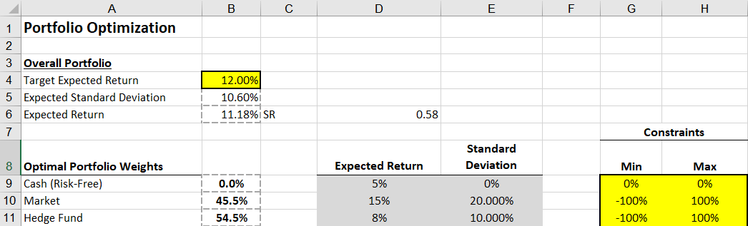

We will invest 45.5% in the market portfolio and 54.5% in the hedge fund, ending up with Sharpe ratio of 0.58

(c) solve alpha/std_fund = 0.5, we have alpha = 5%

3.

(a)

In market model regression:

r_ABC – r_f = alpha + beta * (r_market-r_f) + residue

E(r_ABC) = r_f + alpha + beta*E(r_market – r_f) = 5% + 2% + 1.2 * (15%-5%) = 19%

std(r_ABC) = sqrt( (beta*std(r_market))^2 + std(residue)^2 ) = sqrt((1.2*0.2)^2 + 0.18^2) = 30% since in regression residue and r_market is not correlated

SR_ABC = (E(r_ABC) – r_f)/ std(r_ABC) = 0.4

SR_market = (E(r_market) – r_f) / std(r_market) = 0.5

(b)

Beta = covariance / market variance = corr * std(r_ABC) / std(r_market)

Corr = Beta * std(r_market) / std(r_ABC) = 1.2 * 20% / 30% = 0.8

Using portfolio optimizer:

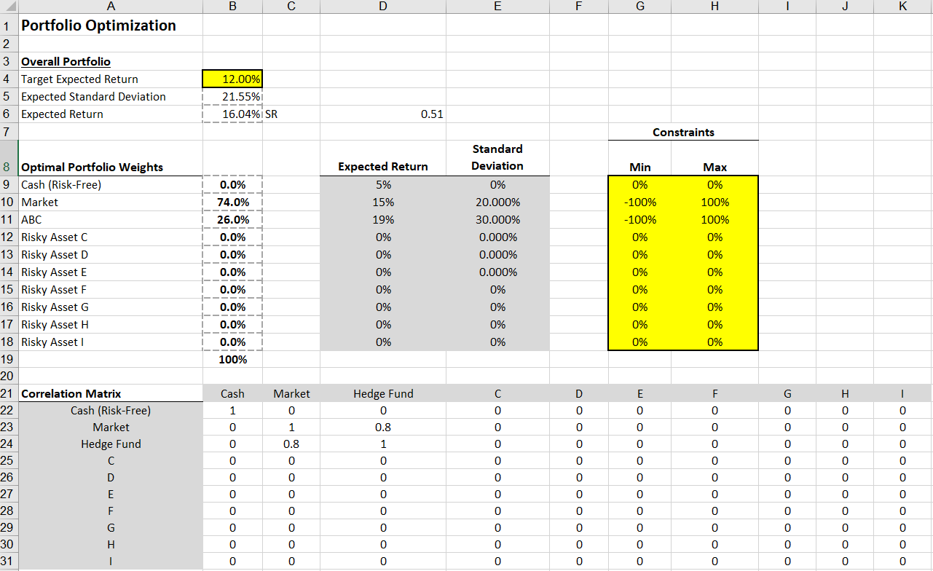

The optimal combination is 74% of market portfolio and 26% of hedge fund ABC

(c)

Only invest in what you know about is not optimal even if what you know about can generate alpha. Apart from alpha, diversification is also a valid source to increase Sharpe ratio, and it is free. Only invest in what you know about does not utilize this free source. As an example above, by leveraging both what you know about (alpha from the hedge fund) and also the diversification from the market portfolio, we can generate higher Sharpe ratio than only invest in hedge fund and the market portfolio.